**HARDWARE COMPONENTS**

The modern computer is a marvel of engineering, a complex system of interconnected components working in harmony to process and present information. Understanding the function of each part, from the motherboard that acts as the central hub to the various ports that connect us to the outside world, is crucial for anyone looking to build, upgrade, or troubleshoot their machine. This overview will explore the key components that make up a computer system, explaining their individual roles and how they contribute to the overall performance and functionality.

1. **Motherboard**

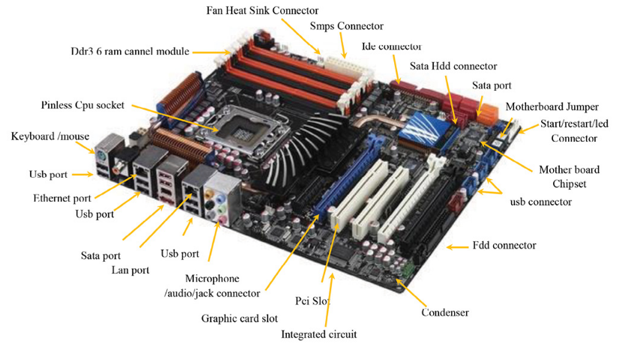

The motherboard is the central nervous system of a computer, the foundational circuit board that connects and coordinates all the other components. It's the backbone upon which the CPU, memory, storage devices, and peripherals all rely. Imagine it as a complex city grid, with roads (buses) and intersections (slots and ports) allowing different parts of the city (components) to communicate and exchange information.At the heart of the motherboard lies the CPU socket, a precisely engineered receptacle for the processor, the computer's brain. The chipset, often considered the motherboard's traffic controller, manages the flow of data between the CPU, memory, and other devices. It determines the capabilities of the motherboard, such as the type and speed of RAM it can support and the number of expansion slots available. RAM slots hold the system's memory, providing the CPU with quick access to data it needs for processing.The motherboard also houses the BIOS or UEFI firmware, a set of instructions that initializes the hardware when the computer is turned on. This firmware performs a self-check and prepares the system for the operating system to load. Power connectors deliver energy from the power supply to the motherboard and its various components.Expansion slots, like PCIe slots, provide a place to install additional components, such as graphics cards for enhanced visuals or network cards for connectivity. Storage interfaces, like SATA and M.2 slots, allow the motherboard to connect to hard drives and SSDs, where the computer stores its data. Modern motherboards also feature a variety of ports on the back panel, including USB ports for peripherals, HDMI and DisplayPort for video output, and Ethernet ports for network connections.The size and layout of a motherboard, known as its form factor (like ATX, Micro-ATX, or Mini-ITX), dictate its compatibility with computer cases. A well-designed motherboard is crucial for ensuring the stability, performance, and upgradability of a computer system. It's the silent workhorse that makes all the other components work together seamlessly.

1. **RAM Modules (Random Access Memory)**

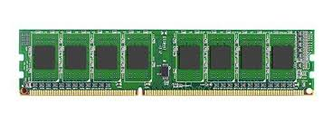

RAM is a type of **volatile memory** that temporarily stores data and instructions needed for active applications, ensuring smooth performance. Unlike storage drives, RAM loses data when power is turned off. It operates at high speeds, significantly impacting system responsiveness. **DDR (Double Data Rate) RAM**, such as DDR3, DDR4, and DDR5, is widely used, with DDR5 offering the highest speeds and efficiency. RAM is available in **various capacities (4GB, 8GB, 16GB, etc.)** and configurations like **single-channel, dual-channel, and quad-channel**, affecting data transfer rates. Specialized RAM, like **ECC (Error-Correcting Code) RAM**, is used in servers for data integrity. The RAM modules are inserted into **DIMM (Dual Inline Memory Module) slots** on the motherboard. Higher RAM capacity and faster speeds improve multitasking, gaming, and overall system performance, making it an essential component for modern computing.

1. **Daughter Cards**

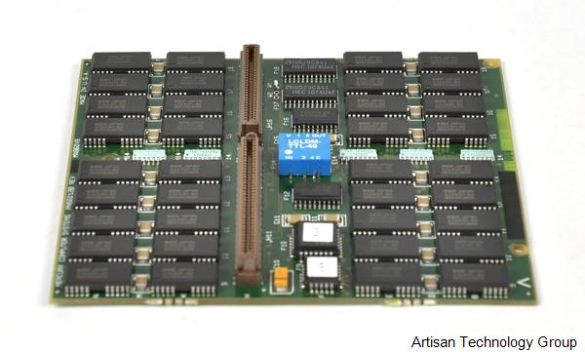

A **daughter card** is an expansion board that connects to the motherboard to enhance or add functionality. These cards are inserted into **PCI, PCIe, or other expansion slots** and allow customization based on computing needs. A **Graphics Processing Unit (GPU)** or **graphics card** is a common daughter card used for gaming, video editing, and AI processing. **Sound cards** improve audio quality for music production and gaming, while **network interface cards (NICs)** enable high-speed wired or wireless internet connectivity. **RAID controller cards** manage multiple storage drives for redundancy and performance improvement. Some daughter cards, like TV tuner cards, provide multimedia functionality. Unlike integrated components, daughter cards allow easy hardware upgrades, improving performance and expanding system capabilities without replacing the entire motherboard. Their modular nature makes them vital for high-performance computing, gaming rigs, and professional workstations.

1. **Bus Slots**

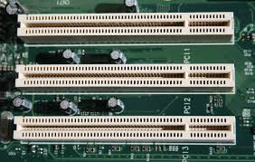

Bus slots are physical connectors on a **motherboard** that allow expansion cards to be installed, enabling communication between components. They are categorized based on speed and function. **PCI (Peripheral Component Interconnect)** was widely used for graphics and network cards but has been replaced by **PCIe (PCI Express)**, which offers multiple lanes (x1, x4, x8, x16) for faster data transfer. **AGP (Accelerated Graphics Port)** was an older slot specifically designed for GPUs but is now obsolete. **ISA and VESA** were used in legacy systems. Modern motherboards primarily feature **PCIe slots**, supporting high-speed GPUs, SSDs, and other expansion cards. **M.2 slots**, commonly found in new systems, are specialized for NVMe SSDs and Wi-Fi cards. The **bus architecture** determines data transfer rates and efficiency, impacting the overall system performance. Choosing the right expansion slot ensures optimal performance for demanding applications like gaming, video editing, and artificial intelligence.

1. **SMPS (Switched Mode Power Supply)**

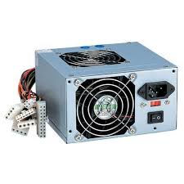

The **SMPS (Switched Mode Power Supply)** converts **AC (Alternating Current)** from the mains into **DC (Direct Current)** at different voltage levels to power a computer. Unlike traditional linear power supplies, SMPS is more efficient, compact, and generates less heat. It provides multiple voltage outputs, typically **3.3V, 5V, and 12V**, to support different components such as the motherboard, CPU, GPU, and storage devices. Common types include **ATX power supplies** for desktops and **SFX power supplies** for compact systems. The **power rating (measured in watts, e.g., 500W, 750W, 1000W)** determines how much energy it can deliver. High-end systems, especially gaming PCs and workstations, require **modular or semi-modular SMPS** for better cable management. Efficiency certifications like **80 Plus (Bronze, Silver, Gold, Platinum, Titanium)** indicate how effectively power is converted. A reliable SMPS ensures system stability, longevity, and protection against power fluctuations.

1. **Internal Storage Devices**

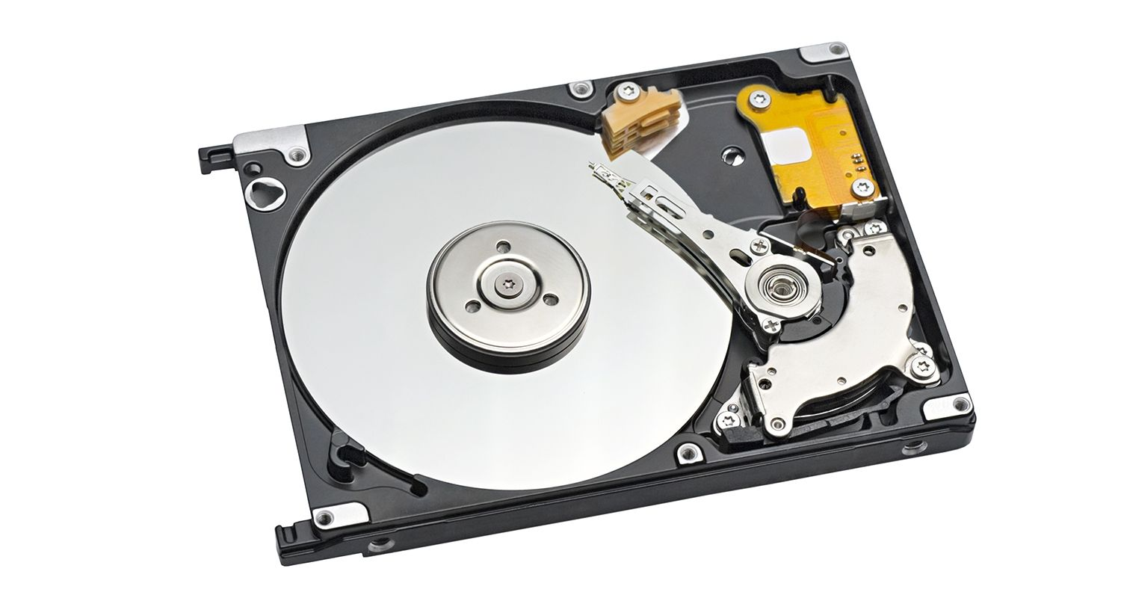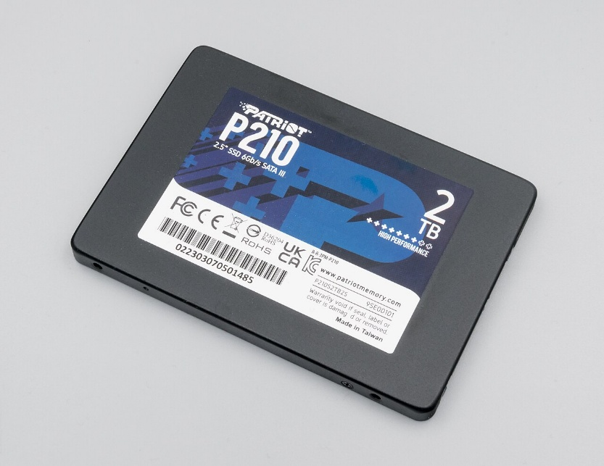

Internal storage devices store operating systems, applications, and user data. The main types are **HDD (Hard Disk Drive)** and **SSD (Solid State Drive)**. HDDs use spinning platters and a magnetic head to read/write data, offering large capacities (up to 18TB) but slower speeds. SSDs use NAND flash memory for faster data access, making them ideal for modern computing. **NVMe (Non-Volatile Memory Express) SSDs** connect via PCIe slots, offering ultra-fast speeds compared to **SATA SSDs**. Some computers use **Hybrid Drives (SSHDs)**, which combine HDD capacity with SSD speed. Enterprise systems utilize **RAID (Redundant Array of Independent Disks)** configurations for data redundancy and performance. Storage is connected through **SATA, PCIe, or M.2 interfaces**. Internal storage devices directly impact boot times, application loading, and system responsiveness. Choosing the right storage solution depends on factors like speed, durability, and capacity needs.

1. **Interfacing Ports**

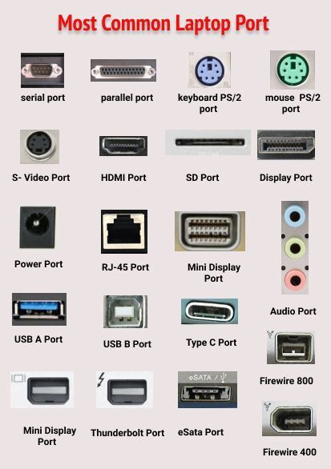

Interfacing ports are connectors that allow external devices to communicate with a computer. **USB (Universal Serial Bus) ports** are the most common, with versions like **USB 2.0, 3.0, 3.1, and USB-C** offering different data transfer speeds. **HDMI (High-Definition Multimedia Interface) and DisplayPort** are used for video output to monitors and TVs, while **VGA** is an older display port. **Ethernet (RJ-45)** enables wired network connections, and **Wi-Fi adapters** may use external ports. **Audio jacks (3.5mm, optical audio)** connect headphones, microphones, and speakers. **Thunderbolt ports**, found in high-end systems, provide ultra-fast data transfer, supporting multiple devices simultaneously. **Serial (RS-232) and parallel ports** were used in legacy systems for printers and industrial machines but are now mostly obsolete. **Power ports**, such as USB-C charging ports, are common in modern laptops. These ports play a vital role in expanding functionality, connectivity, and usability of computing devices.

**Conclusion**

From the intricate circuitry of the motherboard to the high-speed data transfer of NVMe SSDs, each component plays a vital role in the complex ecosystem of a computer. The interplay between these parts determines the overall performance, capabilities, and expandability of the system. Whether it's the rapid access provided by RAM, the enhanced graphics offered by a dedicated GPU, or the stable power supplied by the SMPS, each element contributes to the user experience. Understanding the function and importance of these components empowers users to make informed decisions when building, upgrading, or maintaining their computers, ultimately maximizing the potential of this powerful technology. By appreciating the synergy between these elements, we gain a deeper understanding of the intricate machine that has become such an integral part of our lives.